Preview before normalization:

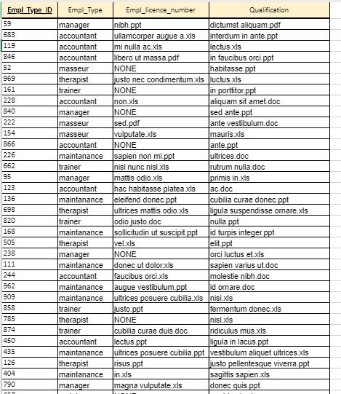

Entity is in 3NF.

PK is employee_type_ID.